Stress-Growth Figures

Andrew Mertens

## Main figures

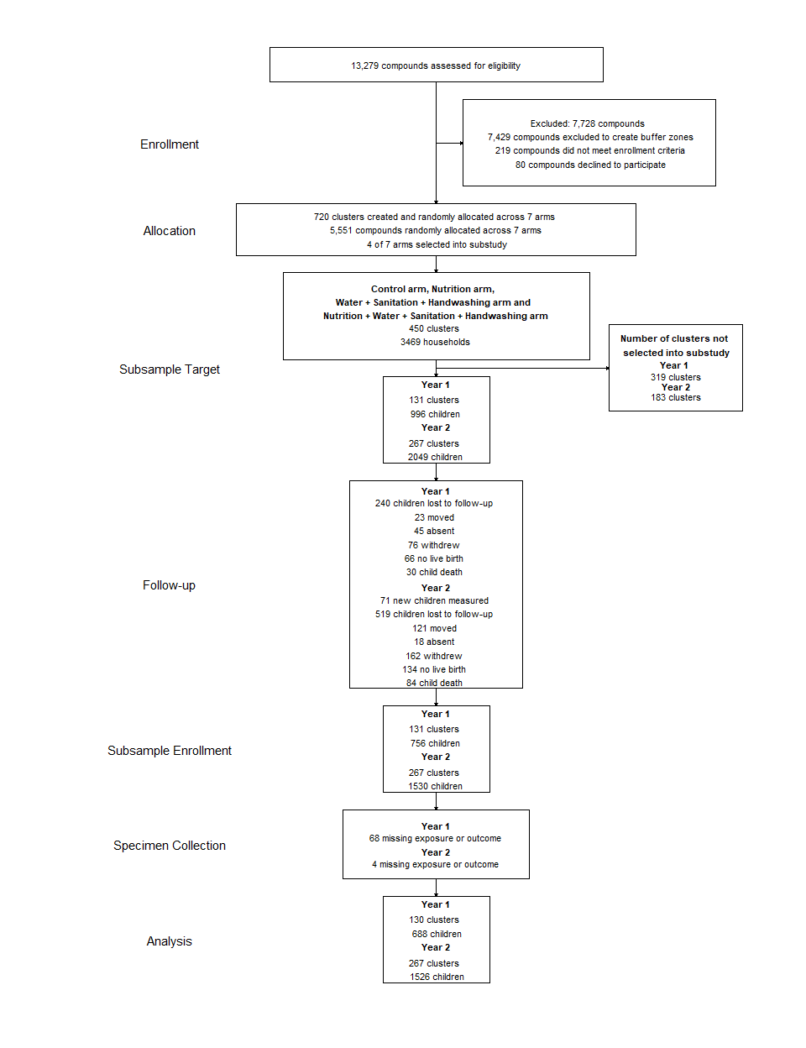

**Figure 1: Participant enrollment, follow-up, and analysis**

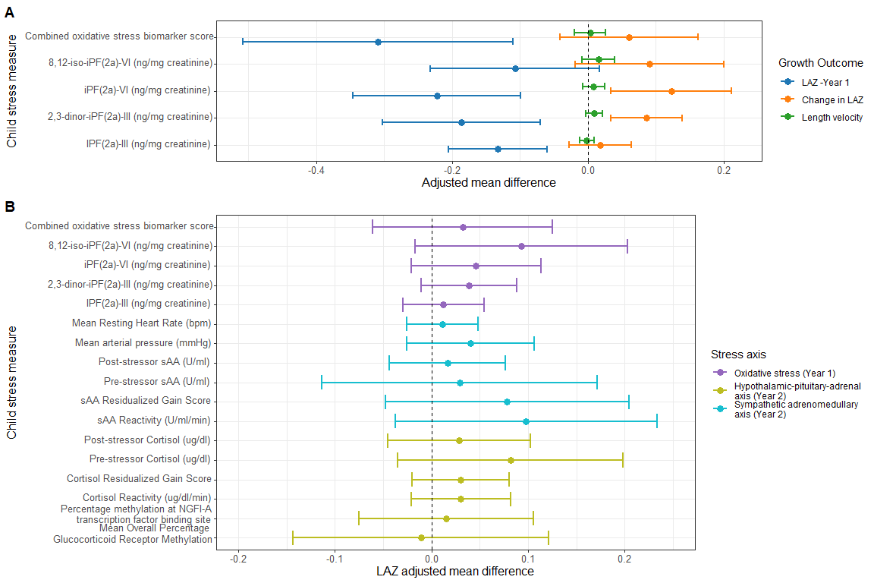

**Figure 2: Plots of associations between child stress measures and linear growth measures**

The differences in child linear growth outcomes at the 75th and 25th percentile of each child stress exposure level and its 95% confidence interval after adjusting for pre-specified covariates, estimated using generalized additive models. Panel A shows associations between urinary isoprostanes, measures of oxidative stress, and child linear growth outcomes at and between the year 1 and year 2 child measurements. Panel B shows associations between HPA axis, and SAM axis, and oxidative stress measures and child LAZ at year 2. The x-axis represents the child stress measure, while the y-axis represents the adjusted mean difference in child growth outcome. The color of the points represents the child growth outcome, with LAZ - Year 2 in blue, WAZ - Year 2 in green, and HAZ - Year 2 in red. LAZ: Length-for-age Z-score; WAZ: Weight-for-age Z-score; HCAZ: Head circumference-for-age Z-score; WLZ: Weight-for-length Z-score; sAA: salivary alpha-amylase.

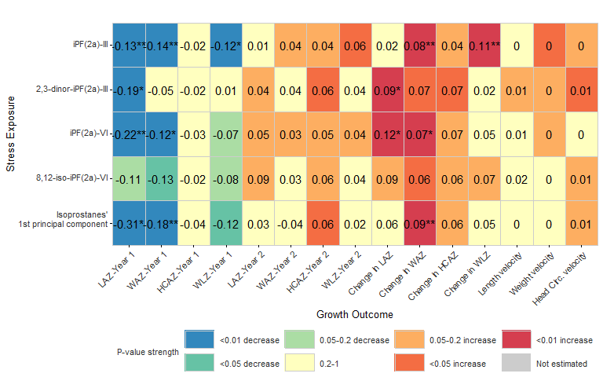

**Figure 3: Heatmap of associations between oxidative stress measures and child growth outcomes**

The heatmap shows the adjusted associations between each urinary isoprostane measure of oxidative stress and child growth outcomes at and between year 1 and year 2. Printed in each cell is the GAM-estimated adjusted mean difference in child growth outcome at the 75th and 25th percentile of each exposure distribution, with the cells colored by the magnitude and direction of the estimated P-values. Estimates are annotated with an asterisk (*) if still significant after FDR correction for multiple comparisons. LAZ: Length-for-age Z-score; WAZ: Weight-for-age Z-score; HCAZ: Head circumference-for-age Z-score; WLZ: Weight-for-length Z-score.

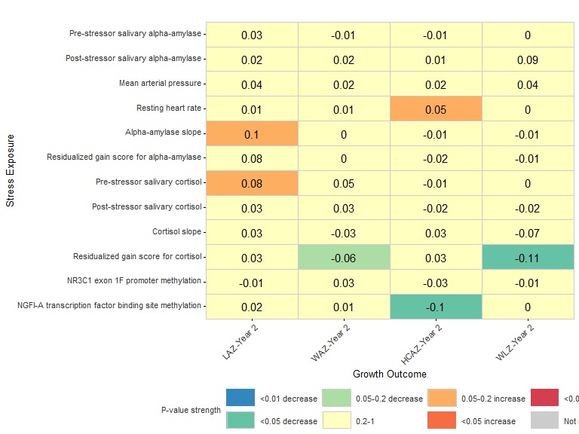

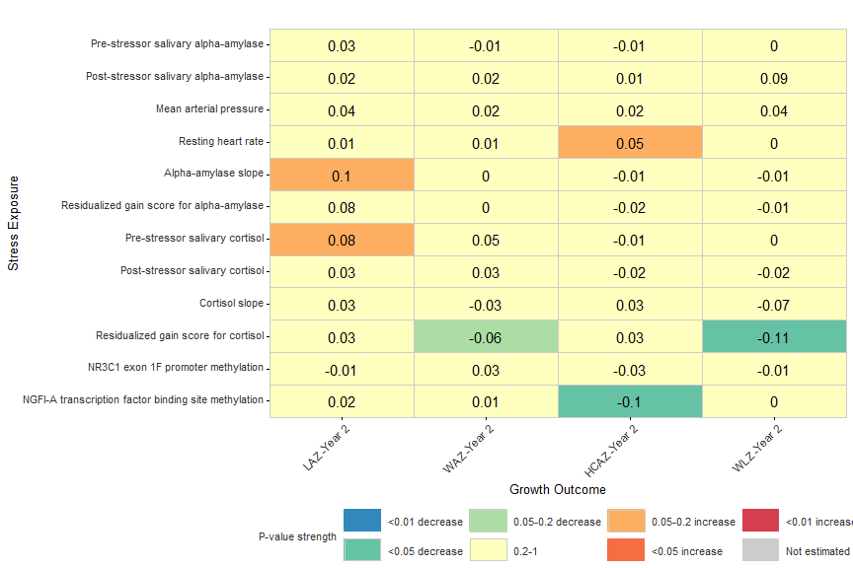

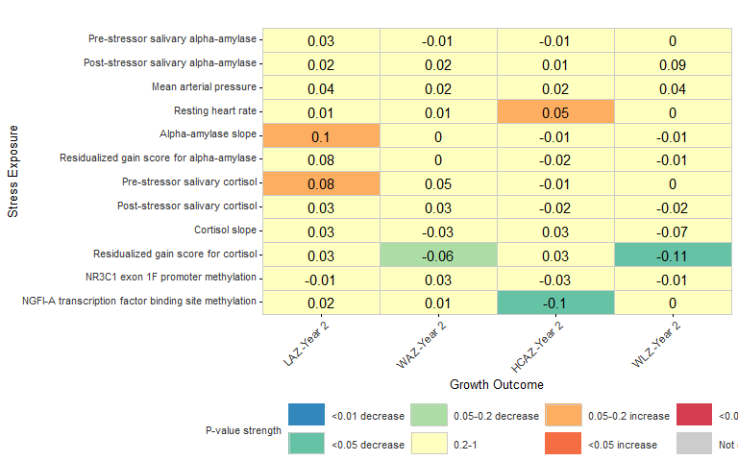

**Figure 4: Heatmap of associations between hypothalamic-pituitary-adrenal axis and sympathetic adrenomedullary axis stress measures and child growth outcomes at year 2**

The heatmap shows the adjusted associations between each stress measure and child growth outcome taken at year 2. Printed in each cell is the GAM-estimated adjusted mean difference in child growth outcome at the 75th and 25th percentile of each exposure distribution, with the cells colored by the magnitude and direction of the estimated P-values. Estimates are annotated with an asterisk (*) if still significant after FDR correction for multiple comparisons. LAZ: Length-for-age Z-score; WAZ: Weight-for-age Z-score; HCAZ: Head circumference-for-age Z-score; WLZ: Weight-for-length Z-score; sAA: salivary alpha-amylase.

## Supplimentary figures

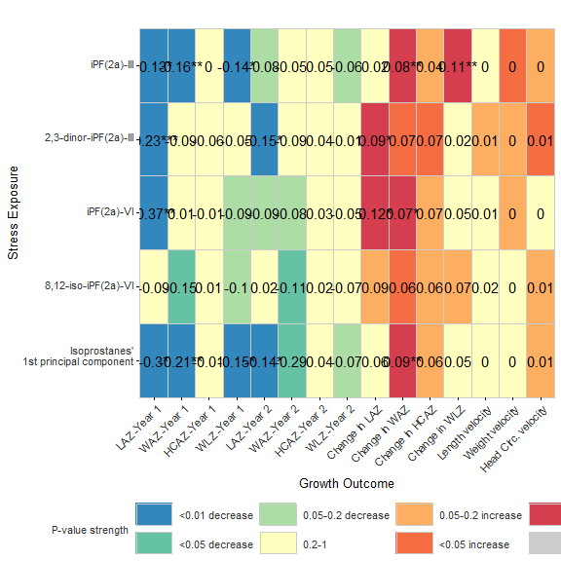

**Figure SX: Heatmap of associations between oxidative stress measures and child growth outcomes estimated without adjusting for prior growth measures**

The heatmap shows the associations between each urinary isoprostane measure of oxidative stress and child growth outcomes at and between year 1 and year 2 when estimated without adjusting for prior child growth. Printed in each cell is the GAM-estimated adjusted mean difference in child growth outcome at the 75th and 25th percentile of each exposure distribution, with the cells colored by the magnitude and direction of the estimated P-values. Estimates are annotated with an asterisk (*) if still significant after FDR correction for multiple comparisons.

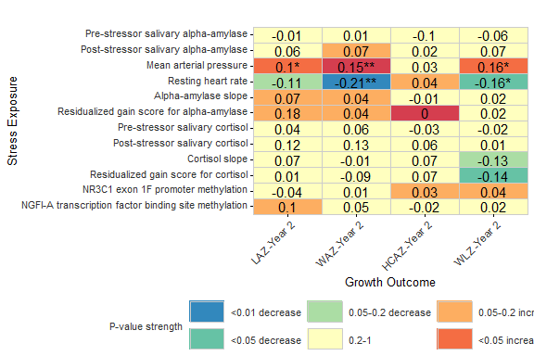

**Figure SX: Heatmap of associations between hypothalamic-pituitary-adrenal axis and sympathetic adrenomedullary axis stress and child growth outcomes estimated without adjusting for prior growth measures**

The heatmap shows the adjusted associations between each stress measure and child growth outcome taken at year 2 when estimated without adjusting for prior child growth. Printed in each cell is the GAM-estimated adjusted mean difference in child growth outcome at the 75th and 25th percentile of each exposure distribution, with the cells colored by the magnitude and direction of the estimated P-values. Estimates are annotated with an asterisk (*) if still significant after FDR correction for multiple comparisons.

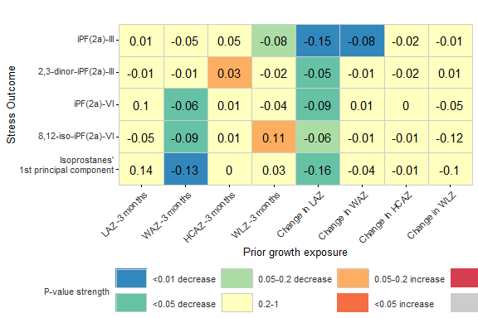

**Figure SX: Heatmap of associations between prior and concurrent child growth and oxidative stress measures as outcomes**

The heatmap shows the associations between prior growth measures as exposures and urinary isoprostane measure of oxidative stress at year 1 as outcomes. Printed in each cell is the GAM-estimated adjusted mean difference in child growth outcome at the 75th and 25th percentile of each exposure distribution, with the cells colored by the magnitude and direction of the estimated P-values. Estimates are annotated with an asterisk (*) if still significant after FDR correction for multiple comparisons.

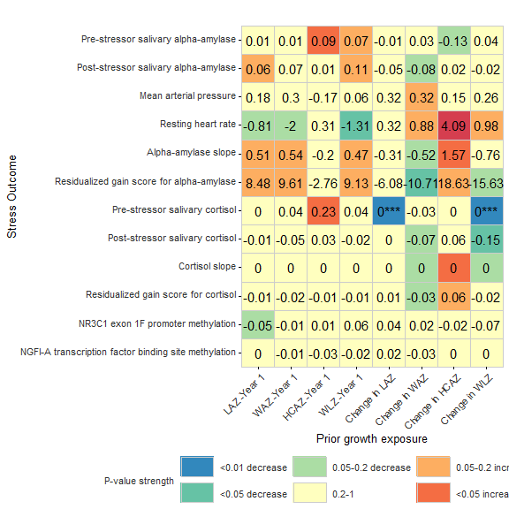

**Figure SX: Heatmap of associations between prior and concurrent child growth and HPA and SAM axis stress measures as outcomes**

The heatmap shows the associations between prior growth measures as exposures and year 2 measures of child stress as outcomes. Printed in each cell is the GAM-estimated adjusted mean difference in child growth outcome at the 75th and 25th percentile of each exposure distribution, with the cells colored by the magnitude and direction of the estimated P-values. Estimates are annotated with an asterisk (*) if still significant after FDR correction for multiple comparisons.

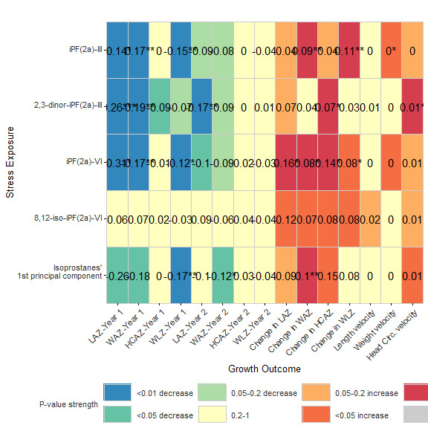

**Figure SX: Heatmap of unadjusted associations between oxidative stress measures and child growth outcomes**

The heatmap shows the unadjusted associations between each stress measure and child growth outcome taken at year 2. Printed in each cell is the GAM-estimated adjusted mean difference in child growth outcome at the 75th and 25th percentile of each exposure distribution, with the cells colored by the magnitude and direction of the estimated P-values. Estimates are annotated with an asterisk (*) if still significant after FDR correction for multiple comparisons.

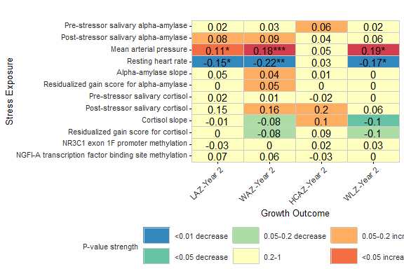

**Figure SX: Heatmap of unadjusted associations between HPA and SAM axis stress measures and child growth outcomes**

The heatmap shows the unadjusted associations between each stress measure and child growth outcome taken at year 2. Printed in each cell is the GAM-estimated adjusted mean difference in child growth outcome at the 75th and 25th percentile of each exposure distribution, with the cells colored by the magnitude and direction of the estimated P-values. Estimates are annotated with an asterisk (*) if still significant after FDR correction for multiple comparisons.

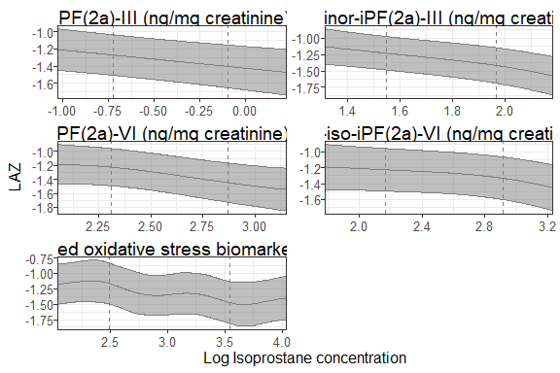

**Figure SX: Spline curves of the associations between concurrent urinary F2 isoprostanes and child LAZ at Year 1.**